International School

Capstone Project 1
CMU-SE 450

Architecture Design
Version 1.2
Date: 13/12/2021

Online Clinic Booking System

Submitted by

Capstone Project 1 - Mentor
PhD Nguyen Tan Thuan Date:
Signature:


Project Information

Project acronym | OnClinic
Project Title | Online Clinic Booking System
Start Date | 23 Aug 2021 | End Date | 12 Dec 2021
Lead Institution
Project Mentor
Scrum master / Project Leader & contact details
Partner Organization | N/A
Team Members
Student ID | Name | Email | Tel

Document Information

Document Title | Architecture Design
Reporting Period
Author(s)
Team members
Date | 13/12/2021
File name | C1SE.37-ArchitectureDesign-OnClinic
Access

Document History
Version | Date | Comments
V1.0 | 04/09/2021 | Create Architecture Document
V1.1 | 15/11/2021 | Additional documents
V1.2 | 13/12/2021 | Completing the document

Table of contents

Project Information 2
Document Information 3
Table of contents 4
1. Introduction 5
1.1. Project overview 5
1.2. Purpose 5
1.3. Business driver 5
2. Architecture driver 6
2.1. Business constraints 6
2.2. Technical constraints 6
2.3. Functional requirement 6
2.4. Quality attributes 7
2.4.1. Security 7
2.4.2. Reliability 7
2.4.3. Performance 8
2.4.4. Usability 9
2.4.5. Correctness 10
2.4.6. Modifiability 10
3. Architecture overview 11
3.1. Component and connector 11
3.2. Module view 13
3.3. Allocation view 15

Introduction

Project overview
The online clinic booking system will build an Android application to help people intelligently book an appointment. Online medical examination support application full of basic features to make healthcare more convenient than ever.

Purpose
This specification covers the following:
- Brief specification of the project, high-level requirement.
- Detail quality attribution.
- System context, sequence diagrams.
- The architecture is presented by various view types: Component and Connect, Module view, and Allocation view.

Business driver
Business Problems:
- Patients need a more convenient way to take care of their health amid the covid 19 pandemic and the 4.0 technology era.
- Patients need a reliable and intelligent tool to help choose the best clinic for them.
- Doctors need a system that can promote their clinic in the information technology era, where everyone owns a smartphone.
Business Need:
- Doctors can post their clinic on the system.
- The system assists patients to book the best clinic, the system will give them top suggestions.
- Doctors can examine and communicate with patients online through video calls, online prescriptions, online payments, clinic reviews.
- Administrators can manage users, clinics…

2. Architecture driver

Business constraints
- Sources: 4 people.
- The project was started on: 23/08/2021
- The project will be ended on: 12/12/2021
- The project will be finished in 112 days (301 hours).
- Cost: 4480$

Technical constraints
Technical to develop:
- Programming Language: Java (use Android Studio), Python.
- Frameworks / Libraries: OpenCV, Real-Time Heart Rate Monitoring From Facial RGB Color Video Using Webcam by H. Rahman, M.U. Ahmed, S. Begum, P. Funk, Jitsi meet.
- Database Real-time Management System: Firebase
Environment:
- App environment: Android
- Developing environment: Android studio

Functional requirement
References to Product Backlog specification (Product Backlog document)

Quality attributes

Security

Scenario: When users (doctor or patient) forget their password and want to reset their password, they must provide the email registered in the system, within 1 minute, a confirmation email will be sent to the email address entered to reset the password forgotten
Type | Security
Stimulus | provide the email registered in the system
Source of stimulus | Users
Environment | In runtime
Artifact stimulated | Application
Response | a confirmation email will be sent to the email address entered to reset the password forgotten
Response measure | within 1 minute

Reliability

Scenario: Users (doctor or patient) want to use the system efficiently, minimize the impact of errors, feel comfortable with the system, so the system will always immediately provide the best user experience
Type | Reliability
Stimulus | want to use the system efficiently, minimize the impact of errors, feel comfortable with the system
Source of stimulus | Users
Environment | In runtime
Artifact stimulated | The system
Response | will provide the best user experience
Response measure | always immediately

Performance

Scenario: Immediately after users (doctor or patient) confirm the clinic booking, the system will confirm and send a notification to the doctor within 5 seconds
Type | Performance
Stimulus | confirm the clinic booking
Source of stimulus | Users
Environment | In runtime
Artifact stimulated | The system
Response | will confirm and send a notification to the doctor
Response measure | within 5 seconds

Scenario: Users (doctor or patient) want to use the application smoothly. So that, the system must handle incoming events with a near-instant delay
Type | Performance
Stimulus | want to use the application smoothly
Source of stimulus | Users
Environment | In runtime
Artifact stimulated | The system
Response | must handle incoming events
Response measure | a near-instant delay

Usability

Scenario: Patients enter their symptoms. The system will predict the disease and make a list of the most suitable clinics for them conveniently and quickly
Type | Usability
Stimulus | enter their symptoms
Source of stimulus | Patients
Environment | In runtime
Artifact stimulated | The system
Response | will predict the disease and make a list of the most suitable clinics for them
Response measure | conveniently and quickly

Scenario: When a patient makes a booking, they can freely choose to see the doctor online or offline, the system will support booking on both forms.
Type | Usability
Stimulus | makes a booking
Source of stimulus | A patient
Environment | In runtime
Artifact stimulated | Mobile devices
Response | will support booking
Response measure | on both forms

Correctness

Scenario: When the patient enters the symptom, the system will diagnose the patient's disease with a high percentage of accuracy
Type | Correctness
Stimulus | enters the symptom
Source of stimulus | the patient
Environment | In runtime
Artifact stimulated | The system
Response | will diagnose the patient's disease
Response measure | a high percentage of accuracy

Modifiability

Scenario: The product manager wants to develop additional features and build a health social network in the next version. The system allows for expansion within 4 months of effort without affecting existing functions.
Type | Modifiability
Stimulus | wants to develop additional features and build a healthy social network
Source of stimulus | The product manager
Environment | the next version
Artifact stimulated | The system
Response | Allows for an expansion
Response measure | 4 person-months of effort without affecting existing functions

Architecture overview
This section shows the diagrams which bound our target system and describes the architecture and interaction between components

Component and connector
We mainly used a C&C view to argue and reason about architectural properties, quality attribute requirements, and functional requirements that the system must add here.
This view type partitions the system into components that have some runtime presence such as processes, objects, data stores, and connectors or that represent pathways of communication such as data flow and access to shared storage.
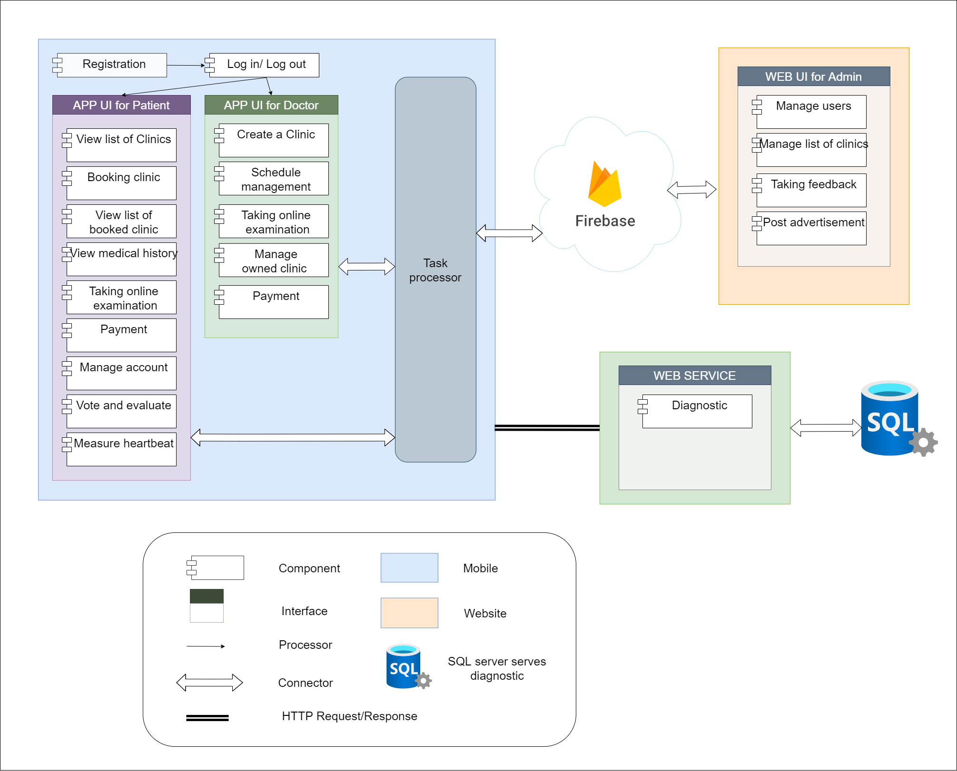
Figure 1: Component and connector view

Explication
Element | Responsibilities
App UI for Patient | Interface with patient-specific features
App UI for Doctor | Interface with doctor-specific features
DB connector | Contains code to communicate with firebase
Firebase service | Service providing real-time data storage solutions
Web UI for Admin | Manage users and clinics through Firebase

Description
After registration, the user will be assigned the default role of a patient, if desired, the patient can register as a partner with OnClinic, after being approved the account will switch to the role of a doctor.
After logging in, depending on the role of the account, the user will access the corresponding interface, each interface will have specific features specific to each role. Requests will be handled through the DB connector to connect and retrieve data with Firebase.

Module view
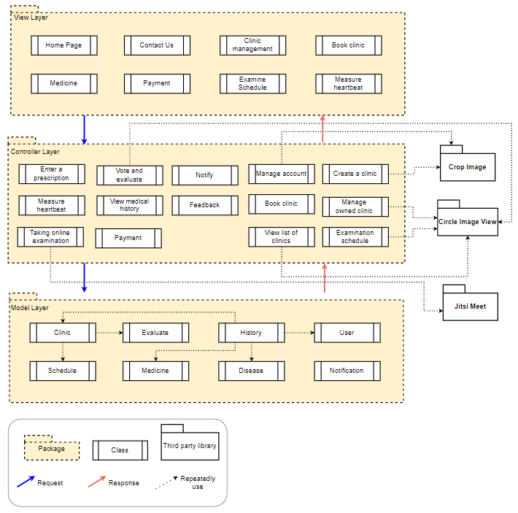
Figure 2: Module View

Explication
Element | Responsibilities
Model layer | Contains system service data
Controller layer | Controls to handle user actions
View layer | Where users interact directly
Crop image | Imported library to crop images
Circle image view | Imported library to round the image
Jitsi meet | A free and open-source video conferencing application

Description
The system consists of 3 layers: Model layer, Controller layer, and View layer.
Users will interact with system features (View layer), interactions will be handled through corresponding controls (Controller layer) to access corresponding data (Model layer).

Allocation view
The allocation view models the run-time architecture of a system. It shows the configuration of the hardware elements when the system is deployed.
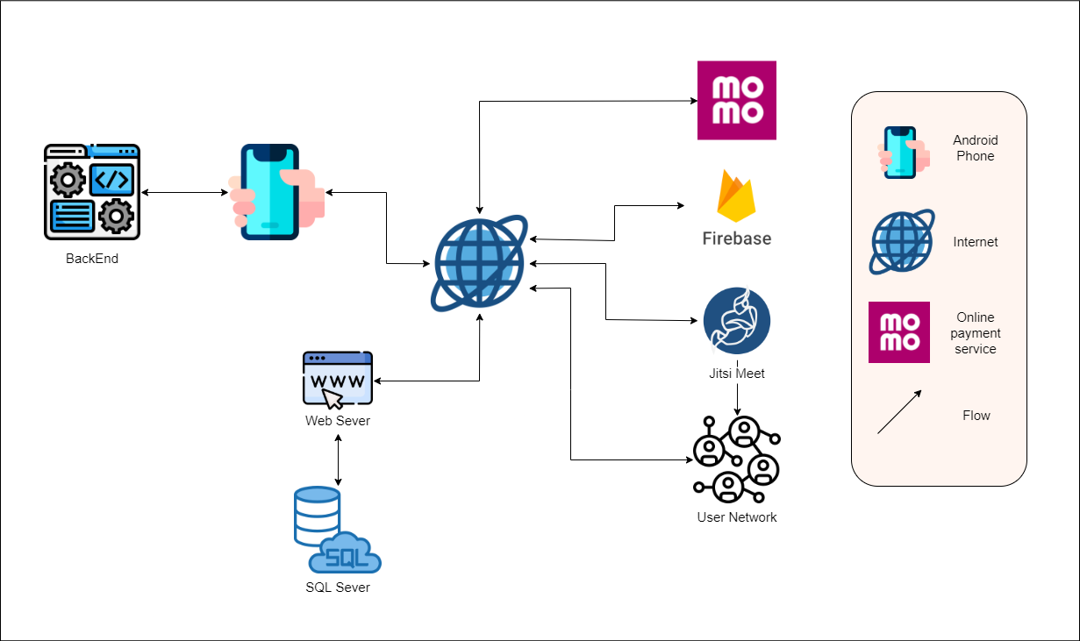
Figure 3: Allocation view

Explication
Element | Responsibilities
Android phone | The device is installed with the application, the user will interact with the system through this device
Back end | Contains codes to handle user actions
Internet | To connect the system to services
Firebase service | Service providing real-time data storage solutions
Jitsi meet | A free and open-source video conferencing application
User network | Network connecting users to use the application
Web service | Handle disease prediction function
SQL server | Contains data serving the webserver

Description
Users will interact with the system through an application on an internet-connected Android smartphone. Through the system, after being connected to the internet, users will use the system's services such as online payment, clinic lookup, online examination, disease prediction, personal information update...

